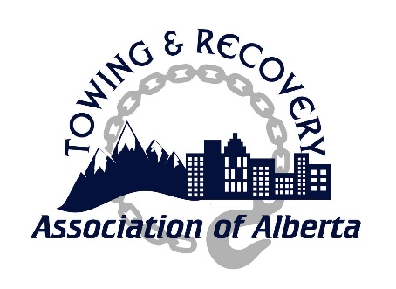
CODE OF ETHICS
ASSOCIATION CORPORATE MEMBERS,
OPERATORS & EMPLOYEES SHALL
Ensure that public safety of consumers, the motoring public and themselves is the most crucial and important factor in any service delivery​
Conduct themselves in a courteous and professional manner and in accordance with the requirements of all appropriate regulations and laws of The Province of Alberta​
Maintain a high standard of business principles and practices and avoid any conduct that would bring discredit upon the towing industry, The Association, or its members​
Project integrity, honour, honesty, and courtesy to all consumers in the delivery of their services​
Not take any action(s) that would abuse public trust or exploit any lack of knowledge or experience of consumers that could cause harm or a misleading impression​
Ensure and respect confidentiality of all consumer information that may become known as a result of any service delivery​
Ensure professional procedures are utilized to manage any type of service delivery​
Ensure that all vehicles utilized in the delivery of services are maintained in a condition that projects a positive public image of the towing industry and The Association​
Refrain from any form of intimidation, harassment or verbal abuse toward consumers, members of the public, emergency responders or other towing operators​
Compete in a fair and honourable manner while never attacking the reputation of a competitor​
Ensure that they are properly qualified to conduct themselves in accordance with the Code of Ethics, regulations or legislation applicable to the towing and recovery industry​
Adhere to this Code of Ethics and abide by any decisions made by the Association Disciplinary Committee for any breach(s) thereof

